**Your Name**: _Areli Isherwood________

**Active Learning partners**:

|  |  |  |
| --- | --- | --- |
|  | Jigsaw Partner on your left | Jigsaw Partner on your right |
| March 29th | Madison Ott | Kathryn Smith |
| April 5th | Kathryn Smith | Madison Ott |

**IMPORTANT NOTE: please remember that you should not share any electronic files with classmates. This includes not sharing the MatLab files or plots that you will be working on in this assignment. Make sure you start with the file attached to the Assignment on Blackboard and work through all of the steps independently on your own. You can verbally ask your classmates who are currently enrolled in BME 282 or who have taken BME 282 in previous semesters about how to do something, but you should not accept or give an electronic copy of a MatLab file, plot, etc. *To receive any credit whatsoever for this assignment, all of the work you submit must be your own work. Also, your name and ASU ID must be included in the titles of ALL MatLab plots!***

**Summary of design process**:

1. In Assignment 3, you were instructed to determine how much enzyme you needed on your test strip to generate a 0.1µA current when a “normal” (~80 mg/dL) drop of blood was placed on the test strip. Why? Using more enzyme would generate a greater current which would require cheaper Op-Amps and result in less signal-to-noise problems so these points seem to argue for you to use more enzyme. For a moment, assume that you decided to use 1 unit of enzyme on an electrode that is 1 mm (0.01 dm) in radius (2 mm in diameter).
   1. Use the Matlab code attached to Assignment 6 on Blackboard to solve the mass transport calculations (by running the function PDEPE) describing glucose concentrations within the drop of blood on the test strip. Insert the plots of (i) 3D plot of glucose concentration vs. distance and time and (ii) Current vs. time here for 1 unit and 1mm radius electrode. **NOTE: you need to change “r” and “unit” both in the assign6.m file and assign6bc.m file – and save the assign6bc.m file before running the simulation from the assign6.m file. Include your name and ASU ID in the titles of ALL MatLab plots!**

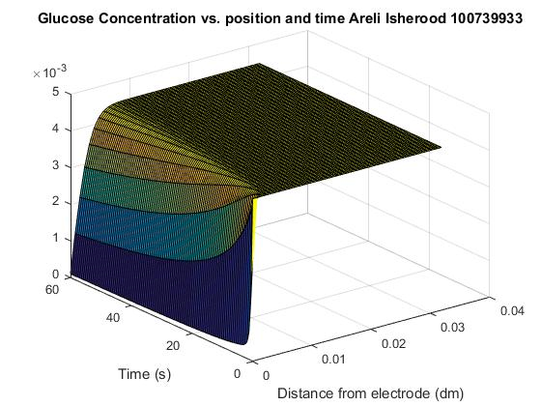

Insert the final graphs you create here.

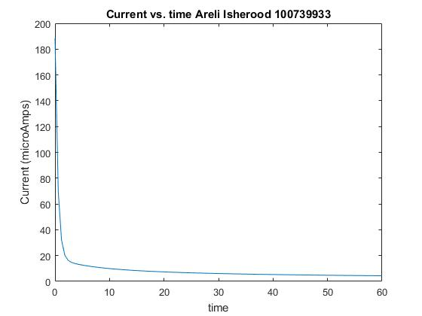

* 1. What percent error does your device record after 5 seconds? 20 seconds? 60 seconds?

Show a sample calculation for at least one of the percent errors you calculate.

device record after 5 seconds: $93.26\% Error$

device record after 20 seconds: 96.1% $Error$

device record after 60 seconds: 97.7% $Error$

$$Percent Error= \frac{|Theoretical Value-Experimental Value|}{Theoretical Value} x 100$$

$$Percent Error at 5 sec= \frac{|188.6-12.7|}{188.6} × 100=93.26\%$$

$$Percent Error at 20 sec= \frac{|188.6-7.396|}{188.6} × 100=96.1\%\%$$

$$Percent Error at 60 sec= \frac{|188.6-4.36|}{188.6} × 100=97.7\%$$

1. You have chosen to instead use a smaller amount of enzyme to minimize the error you just noted in Part 1b. Look back to your answer to Assignment 3 and use the amount of enzyme you thought would yield a current of 0.1µA for a 80mg/dL sample. Or, if you have reconsidered that answer, use an updated amount of enzyme that you think is appropriate for your test strips.

$$Amount of Enzyme from Assingment 3: 1.38×{10}^{-8} \frac{mol}{L}$$

$$Updated Amount of Enzyme 5.3×{10}^{-4} \frac{μmol}{min}$$

*Conversion calculations are in my notebook.

* 1. Use the Matlab code attached to Assignment 6 on Blackboard to solve the mass transport calculations (by running the function PDEPE) describing glucose concentrations within the drop of blood on the test strip. Insert the plots of (i) 3D plot of glucose concentration vs. distance and time and (ii) Current vs. time here for the number of units that you will actually use on your test strip and the radius for the electrode that you will actually use. Document all of the variations you try in your logbook and note the reasons for why you feel confident that your final answer is the best choice of all possible amounts of enzyme / electrode radius combinations. **NOTE: you need to change “r” and “unit” both in the assign6.m file and assign6bc.m file – and save the assign6bc.m file before running the simulation from the assign6.m file. Include your name and ASU ID in the titles of ALL MatLab plots!**

Changed Units to: 5.3e-4

Changed Radius to: 0.02

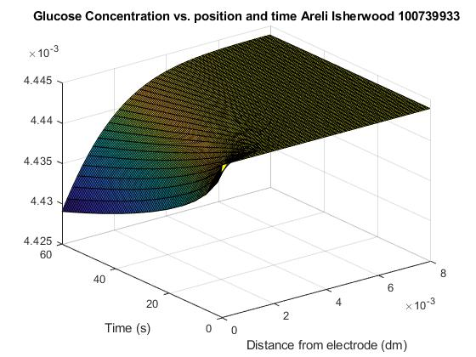

Insert the final graphs you create here.

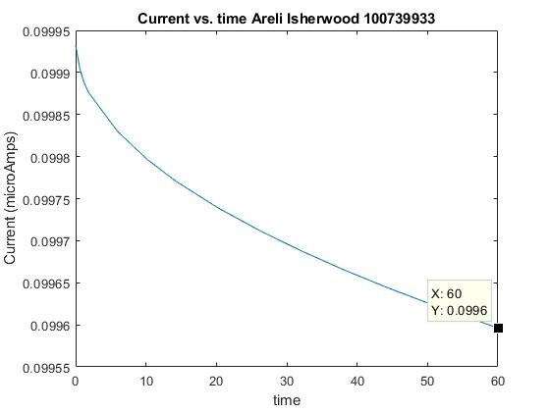

* 1. What percent error does this simulation predict for your device (with the choices you’ve made for amount of enzyme and electrode radius) record after 5 seconds? 20 seconds? 60 seconds?

Show a sample calculation for at least one of the percent errors you calculate.

device record after 5 seconds: $0.09$% $Error$

device record after 20 seconds: $0.19$% $Error$

device record after 60 seconds: $0.33$% $Error$

$$Percent Error= \frac{|Theoretical Value (value at zero)-Experimental Value|}{Theoretical Value} x 100$$

$$Percent Error= \frac{|0.09993-0.09984|}{0.09993} × 100=0.09\%$$

$$Percent Error= \frac{|0.09993-0.09974|}{0.09993} × 100=0.19\%$$

$$Percent Error= \frac{|0.09993-0.0996|}{0.09993} × 100=0.33\%$$

1. [OPTIONAL: 5 points EXTRA CREDIT]

(***Getting these extra credit points seems like a lot of work for 5 measly points.*** And it is. However, even if you elect not to do it, you ought to look it over. The final assignment, which will be worth 30% of your grade, has a lot in common with this extra credit exercise. And there’s not all that much time allotted for you to complete the final assignment. So, having at least thought through the issues raised here is probably a good idea.)

**Connect the dots**: As you are seeing, the output of one component (e.g, test strip outputs electric current) is the input to the next component (e.g., electric current is the input to the current-to-voltage conversion circuit) and so forth, which means that any change in design has a ripple effect throughout your choices for all other components in the entire device. The mass transport calculation above may have changed the amount of enzyme that you intend to use and also shows that the current will change with time as the enzyme depletes the glucose in the blood samples (although you’ve tried to minimize that above).

For this EXTRA CREDIT section, make sure that all of your design choices/calculations are consistent in the sense that the amount of enzyme, current generated, op-amp/battery/resistor choice, accuracy assumed, etc., are all consistent with each other.

To do this, go back through your calculations for each of the previous assignments using the optimal value of enzyme amount used in Part 2 of this assignment. Also base your current generated by the test strip on the plot of Current vs. time that you generated in Part 2 of this assignment. If this requires you to choose a new combination of op-amp/battery/resistor to be compatible with the current generated above in Part 2, choose and justify new choices for op-amp/battery/resistor.

The error you estimated in Part 2b above should lead you to re-evaluate your answer to Part 2 of Assignment 5 (probability of serious adverse event) – this will be more likely because the amount of time before a reading will become a source of error. Take the data used in your Assignment 5 standard deviation calculations, calculate percent error of those from the mean value you calculated, add or subtract (make worse) the percent error your calculated above in Part 2b (justify your choice of time point used in that exercise), convert back to concentration, then calculate a new (and worse) standard deviation. Repeat the probability exercise you performed in Part 2 of Assignment 5 to estimate the number of severe adverse events that will occur each year.

List your final choices for amount of enzyme, op-amp/battery/resistor combination, and estimate of number of serious adverse events per year here:

Show the critical calculations you performed and summarize your thought process in arriving at the above choices here:

**Instructions for turning in Assignment 6:**

1. **Upload** your worksheet in either Word or PDF format to Blackboard (**due on before the class starts on Thursday, April 12th**)
2. **At the beginning of class on April 12th**: **Turn in** a hard copy of the worksheet (PDF or Word format) AND a copy of the pages in your notebook for this assignment. You may also opt to turn in at the same time a Word document with your explanatory essay.